Richmond County Center
123 Caroline Street
Rockingham

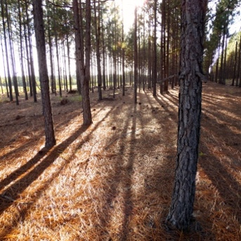
Did you know?
- Richmond County has about 221,406 acres of privately owned timberland

- Landowners received about $12 million harvest value in 2016
- The total economic impact of the forestry industry is $389.3 million

Forestry Workshop Series
All programs at 123 Caroline Street, Rockingham

Tuesday, March 10, 2020: Selling Your Timber, Dr. Robert Bardon,
NCSU, Extension Forestry, 6:00-8:00 pm
The Sandhills Prescribed Burn Association is sponsoring a meal with this program.
RSVP is required by Friday, March 6, 2020.

Tuesday, March 17, 2020: Importance of Forestry Plans, 6:30-8:00 pm
Tuesday, March 31, 2020: Seeking assistance from a Forestry Professional,
6:30-8:00 pm
Tuesday, April 7, 2020: Forest Product Markets – Current Conditions, Future
Trends 6:30-8:00 pm

Programs are free, but registration is required
Call 910-997-8263 or email paige_burns@ncsu.edu
A minimum of 7 participants is needed for each workshop
Accommodation requests related to a disability should be made by March 2, 2020 to Paige Burns Clark, 910.997.8255, lpburns@ncsu.edu. N.C. Cooperative Extension prohibits discrimination and harassment regardless of age, color, disability, family and marital status, gender identity, national origin, political beliefs, race, religion, sex (including pregnancy), sexual orientation and veteran status. NC State University, N.C. A&T State University, U.S. Department of Agriculture and local governments cooperating.

